Single Sign On (SSO)

Steps to configure SSO for Zwayam platform on Azure AD:
Step1: Go to the Azure Active Directory Admin Center with admin privileges.

Step2: On the Home page select ‘Enterprise applications’ under ‘Azure App gallery’ and search for Zwayam SSO.
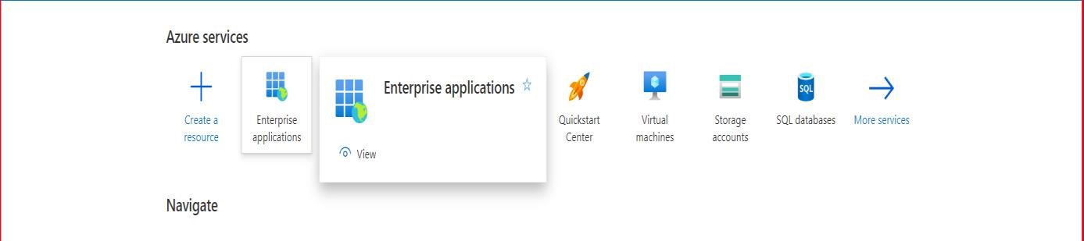

Step3: In the Manage section of the left menu, select Single sign-on to open the Single sign-on pane for editing.

Step4: Select SAML to open the SSO configuration page. After the application is configured, users can sign in to it by using their credentials from the Azure AD tenant.

Step5: On the Set up single sign-on with SAML page, click the pencil icon for Basic SAML Configuration to edit the settings.

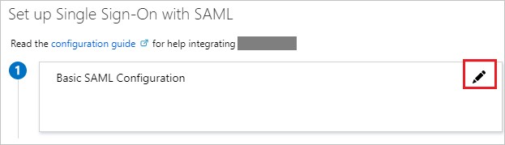

Step6: Select Edit in the Basic SAML Configuration section on the Set up single sign-on pane.

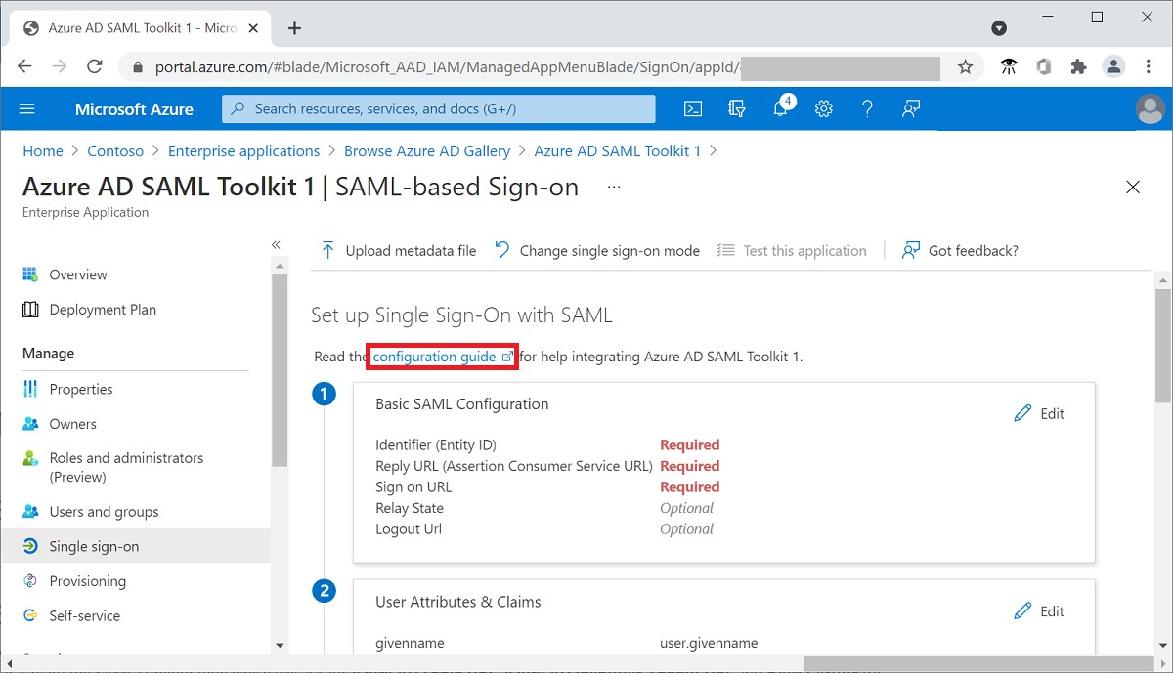
Step7: Enter the following URLs for preproduction servers:
Entity ID: https://sso-preprod.zwayam.com/zwayam-saml/saml/metadata
ACS URL: https://sso-preprod.zwayam.com/zwayam-saml/saml/SSO
Sign on URL : https://sso-preprod.zwayam.com/zwayam-saml/saml/SSO

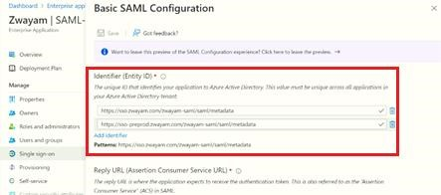

Step8: Enter the details and Save
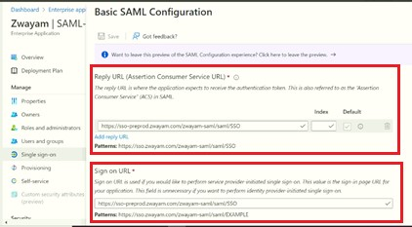

Step9: Download the Certificate and Metadata for Preprod. Share these files with Zwayam team

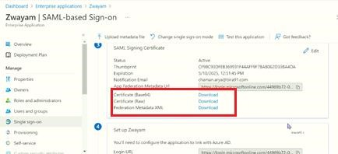

Note: Zwayam team will use shared Certificate & Metadata file to configure SSO in Preprod environment. Below steps for Production needs to be followed after testing is completed in Preprod.

Step10: Repeat the steps from point no. 1-8 for Production server

Step11: Use these below URLs for Production server
Entity ID: https://sso2.zwayam.com/zwayam-saml/saml/metadata
ACS URL: https://sso2.zwayam.com/zwayam-saml/saml/SSO
Sign on URL : https://sso2.zwayam.com/zwayam-saml/saml/SSO
Step12: Download the Certificate and Metadata for Production server after entering the details
Step13: Save it on your computer and share with Zwayam team.

